STEP 1.
Click on “register / регистрация” on the website homepage.
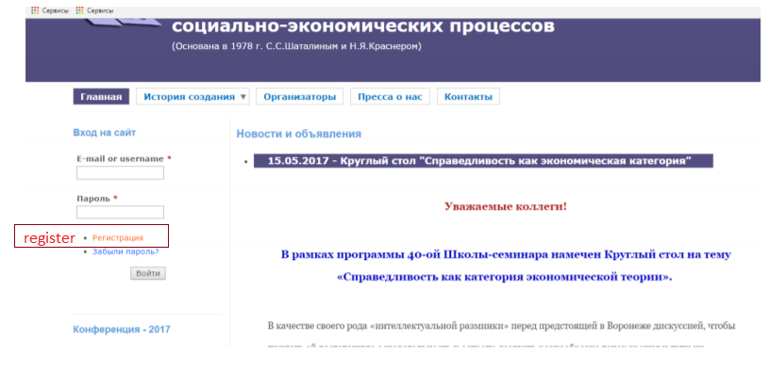
Step 2.
Fill in the registration form.
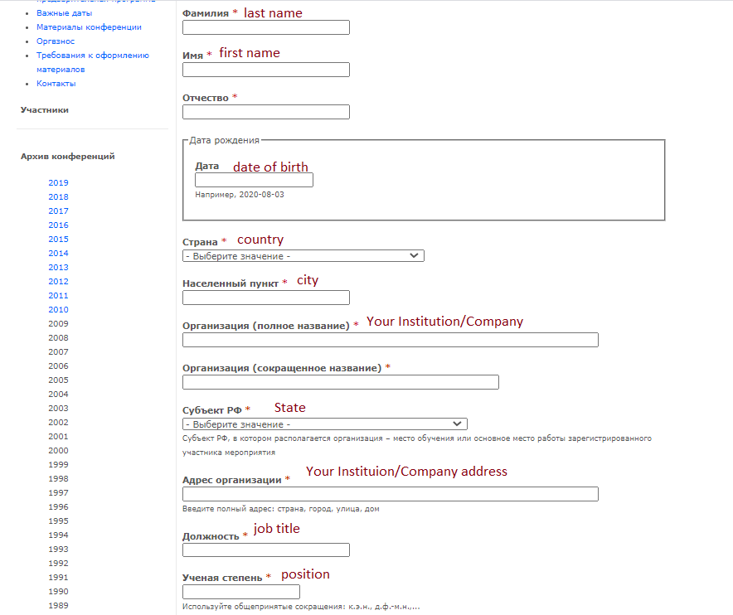
STEP 3.
Check your mailbox and follow further instructions.
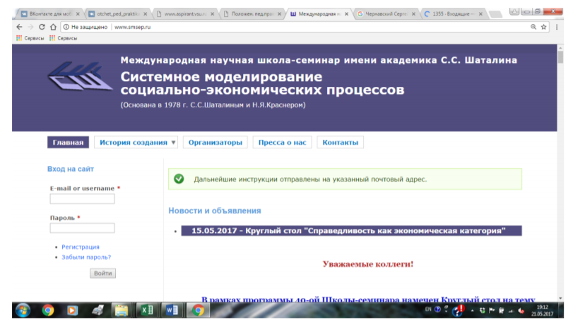
STEP 4.
Create your password.
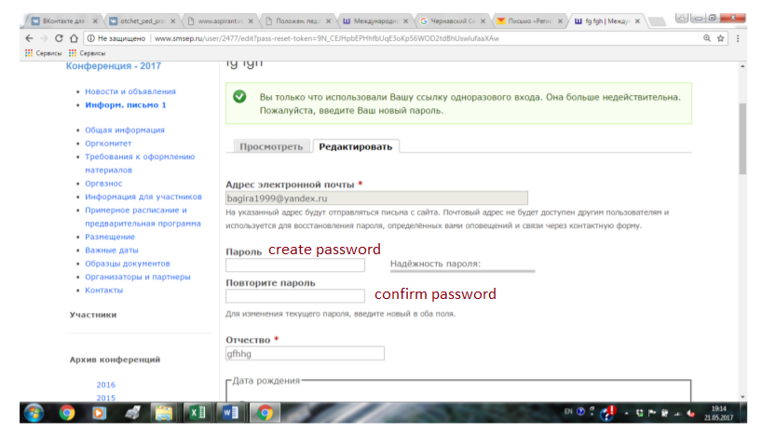
STEP 5.
Sign in your account.
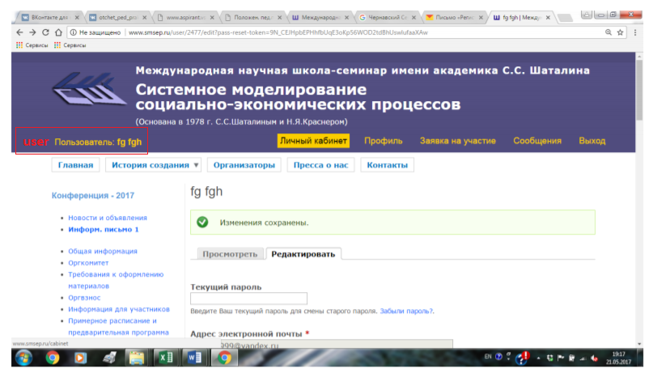
STEP 6.
View/edit the application for the current conference
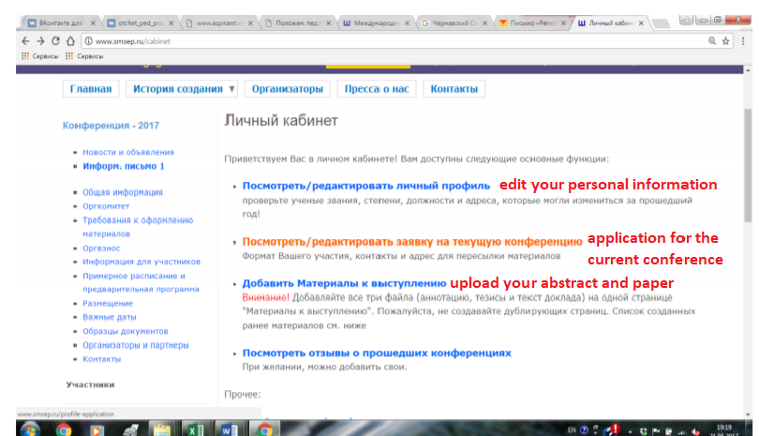
STEP 7
Click on “Edit/редактировать”
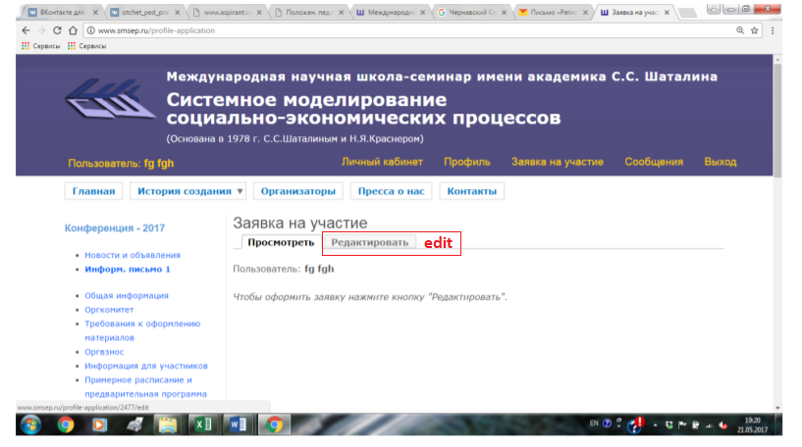
STEP 8
Fill in the application form with additional information
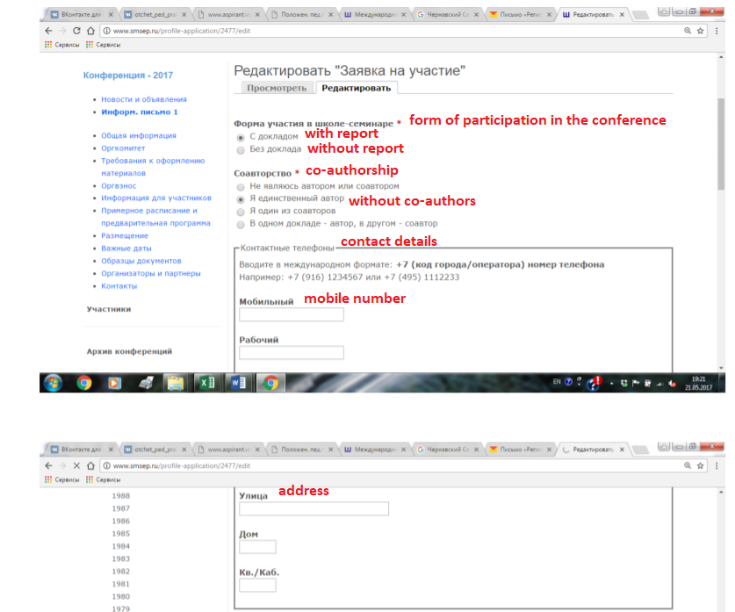
Click on “Save”
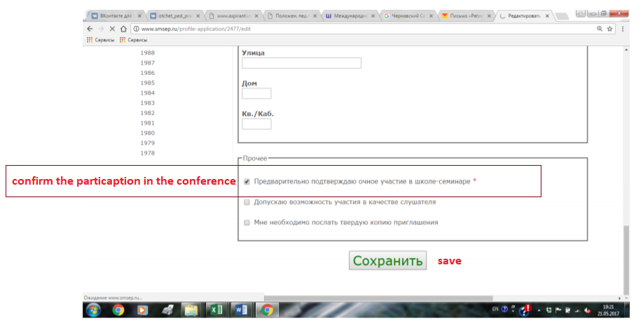
STEP 9
Sign in and click on “upload your abstract and article / добавить материалы к выступлению”.
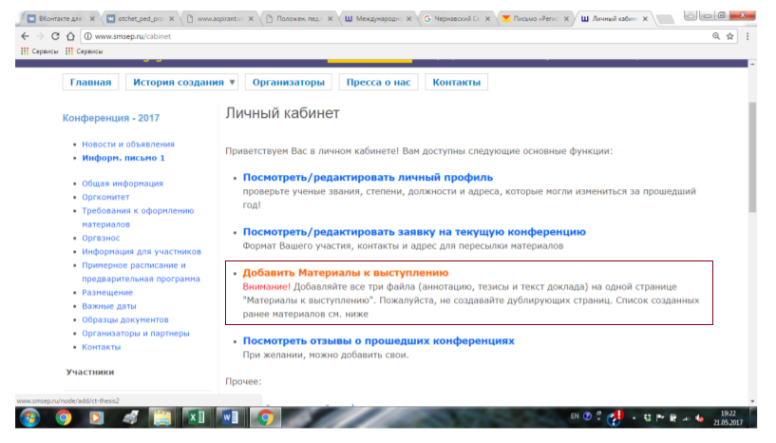

STEP 10
Fill in the following form, dedicated to your report:
Enter the title and co-authors (in case you have co-authors)
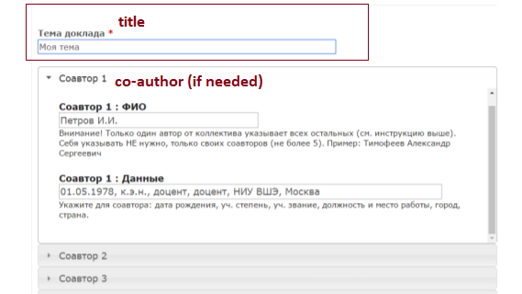
Choose the format of participation
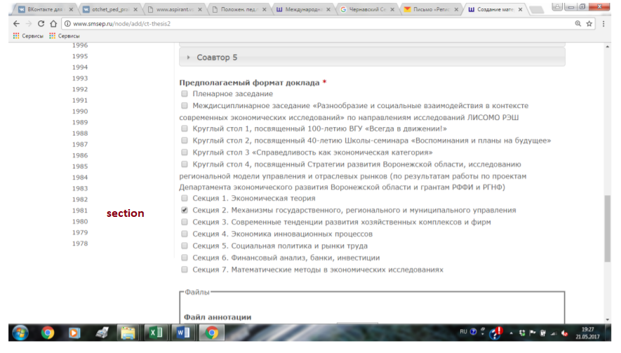

And, finally, upload your abstract, article and full report. Please, don’t forget to follow article submission guidelines (see in the information letter).
