Department of Social Sciences RAS
Federal State Budgetary Institution of Science
Central Economic and Mathematical Institute RAS
Federal State Educational Institution
of higher education "Voronezh State University"
Federal Research Center "Informatics and Management"
(Russian Academy of Sciences Institute for Systems Analysis)
Higher education and research institute
"The New Economic School"

INFORMATION LETTER

Dear Colleagues!
We are delighted to invite you to participate in
The 43rd Annual International Conference
"System modeling of social and economic processes"
named after academician S.S. Shatalin
The conference
will be held virtually
on 13-18 October 2020

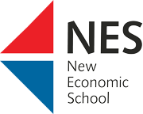
ORGANIZING COMMITTEE:
Co-Chairs:
- Makarov Valery Leonidovich - Academician of the Russian Academy of Sciences, Scientific Director of the CEMI of the Russian Academy of Sciences, President of the New Economic School, Director of the Higher School of Economics, Moscow State University named after M.V. Lomonosov, Moscow
- Yendovitskiy Dmitry Alexandrivich – Doctor of Economics, Professor, Acting Rector of VSU
Deputy Chairmen:
- Grebennikov Valery Grigorievich - Doctor of Economics, Professor, Chief Scientific Officer of CEMI RAS, Moscow (chairman of the program committee)
- Shchepina Irina Naumovna - Doctor of Economics, Assoc. Professor, R&D Deputy Dean of Econ. Faculty, VSU, Voronezh; Chief Scientific Officer of CEMI RAS, Moscow (head of the working group)
Program committee:
- Afanasyev Mikhail Yuryevich - Doctor of Economics, Professor, Chief Scientific Officer CEMI RAS, Moscow
- Bakhtizin Albert Raufovich - corresponding member. RAS, Doctor of Economics, Prof., Director of CEMI RAS, Moscow
• Weber Shlomo - Ph.D., prof., Presedent of NES, scientific. hands. Social Relations and Diversity Research Laboratories (LISOMO), NES, Moscow, Emeritus Professor of Economics, Southern Methodist University in Dallas, USA
• Dementyev Viktor Evgenievich - Corresponding Member. RAS, Head of Scientific Direction, CEMI RAS, Moscow
• Kleiner Georgy Borisovich - Corresponding Member. RAS, head of the scientific direction CEMI RAS, head. Department of the Financial University under the Government of the Russian Federation, Moscow
• Livshits Veniamin Naumovich - Doctor of Economics, Prof., Head. laboratory of FRC IU RAS, chief researcher CEMI RAS, Moscow (Deputy Chairman of the Program Committee)
• Polterovich Victor Meerovich - Academician of the Russian Academy of Sciences, Deputy. Director of the MSE MSU, head of the scientific direction of the CEMI RAS, head. Laboratory of IE RAS, Moscow
• Ustyuzhanina Elena Vladimirovna - Doctor of Economics, Associate Professor .., Chief Researcher CEMI RAS, prof. PRUE named after G.V. Plekhanova, Moscow (Deputy Chairman of the Program Committee, Head of the Expert Group)
Organizing Committee:
• Azarnova Tatyana Vasilievna - Doctor of Technical Sciences, Head. Department of the Faculty of PMM, Voronezh State University, Voronezh
• Anopchenko Tatyana Yurievna - Doctor of Economics, Professor, Dean of the Faculty of Economics and Management, Advisor to the Rector of SmolSU
• Baeva Nina Borisovna - Candidate of Economic Sciences, Assoc. Faculty of PMM, Voronezh State University, Voronezh
• Davydov Denis Vitalievich - Doctor of Economics, Associate Professor, Deputy. Head of the Central Bank of the Russian Federation, Vladivostok
• Golichenko Oleg Georgievich - Doctor of Economics, Prof., Chief Researcher CEMI RAS, Moscow
• Kanapukhin Pavel Anatolyevich - Doctor of Economics, Dean of the Economy. Faculty of Voronezh State University, Voronezh
• Kachalov Roman Mikhailovich - Doctor of Economics, Prof., Chief Researcher CEMI RAS, Moscow
• Kvint Vladimir Lvovich - Doctor of Economics, Prof., Head. Department of the Moscow School of Economics, Chief Researcher CEMI RAS, head. Department of the North-West Institute of Management, RANEPA, foreign member of the Russian Academy of Sciences, USA
• Kuboniva Maasaki - prof. Hitotsubishi University, Tokyo, Japan
• Silaev Andrey Mikhailovich - Doctor of Physical and Mathematical Sciences, Prof., Head. Department of Higher School of Economics - Nizhny Novgorod, Nizhny Novgorod
• Sonin Konstantin Isaakovich - Candidate of Physical and Mathematical Sciences, prof. University of Chicago (The University of Chicago Irvin B. Harris Graduate School of Public Policy), Chicago, USA
• Filatov Alexander Yurievich - PhD in Physics and Mathematics, Associate Professor, Scientific Supervisor of the Research Laboratory of the School of Economics and Management, FEFU, Vladivostok
• Mohsin U. Khan - Ph.D., Prof., Secretary, Zaheer Science Foundation, New Delhi, India
Expert group:
• Gogoleva Tatyana Nikolaevna - Doctor of Economics, Prof., Head. Department of Economics. Faculty of Voronezh State University, Voronezh
• Denisova Irina Anatolyevna - Ph.D., Candidate of Economic Sciences, Associate Professor of the Faculty of Economics, Moscow State University, prof. NES, Leading Researcher, CEMI RAS, Moscow
• Dolgopyatova Tatyana Grigorievna - Doctor of Economics, Prof., Chief Researcher, Ordinary Prof. Faculty of Economic Sciences, National Research University Higher School of Economics, Moscow
• Levin Mark Iosifovich - Doctor of Economics, prof., Ordinary prof. Faculty of Economic Sciences, National Research University Higher School of Economics, Chief Researcher CEMI RAS, Moscow
• Maksimov Andrey Gennadievich - Candidate of Physical and Mathematical Sciences, Head. department NRU HSE - Nizhny Novgorod, Nizhny Novgorod
• Petrov Alexander Georgievich - Candidate of Economic Sciences, Senior Researcher CEMI RAS, Moscow
• Pokrovsky Dmitry Alexandrovich - Ph.D. in Economics, Associate Professor, Department of Economics, National Research University Higher School of Economics - St. Petersburg, St. Petersburg
• Tatyana Anatolyevna Ratnikova – PhD in Physics and Mathematics, Associate Professor of the Department of Applied Economics, National Research University Higher School of Economics, Moscow
• Savvateev Alexey Vladimirovich - Doctor of Physical and Mathematical Sciences, Rector of the Dmitry Pozharsky University, Leading Researcher CEMI RAS, professor at Moscow Institute of Physics and Technology, scientific supervisor of the Central Economic School of Economics, Moscow; Scientific director of the Caucasian Mathematical Center at ASU together with MIPT, Maykop
• Ugolnitsky Gennady Anatolyevich - Doctor of Physical and Mathematical Sciences, Prof., Head. department Institute of Mathematics, Mechanics and Computer Science named after I.I. Vorovich SFedU, Rostov-on-Don
Conference organizers:
- Bregeda Maxim Viktorovich – Ph.D. in Economics, Deputy. fin. Director for Analytics "IM-Logistics", Moscow
- Burilina Maria Alekseevna - research assistant CEMI RAS, Moscow
- Borodina Anna Aleksandrovna - post-graduate student of econom.faculty of Voronezh State University, Voronezh
- Bystryantseva Daria Igorevna - lead. engineer, teacher econom. faculty of Voronezh State University, Voronezh
- Voronova Polina Aleksandrovna - laboratory assistant, econom. faculty of Voronezh State University, Voronezh
- Zhdanova Olga Vitalievna - teacher. economy. Faculty of Voronezh State University, Voronezh
- Imanov Rafail Arifovich - Ph.D. in Economics, Senior Researcher CEMI RAS, Moscow
- Kovyrshina Olga Igorevna –post-graduate student of econom.faculty of Voronezh State University, Voronezh
- Maslova Marina Igorevna - lead. engineer, teacher econom. faculty of Voronezh State University, Voronezh
- Ponomareva Olga Stanislavna - Senior Researcher CEMI RAS, Moscow
- Pimenova Christina Alexandrovna – undergraduate of econom. faculty of Voronezh State University, Voronezh
- Solosina Maria Igorevna - lead. engineer, econom. Faculty of Voronezh State University, Voronezh
- Shchepin Lev Alekseevich – post-graduate of faculty of AMM, Voronezh State University, Voronezh
- Yurova Yana Aleksandrovna - teacher. econom. faculty of Voronezh State University, Voronezh
- Yaryshina Valeria Nikolaevna - Ph.D. in Economics, Assoc. Professor, Leading. engineer, econom. faculty of Voronezh State University, Voronezh

Conference partners

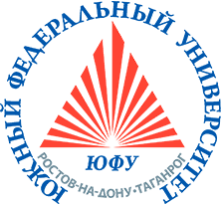
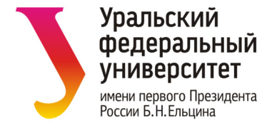 | Университет Дмитрия Пожарского | 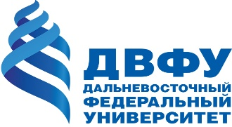
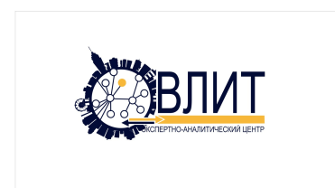 | 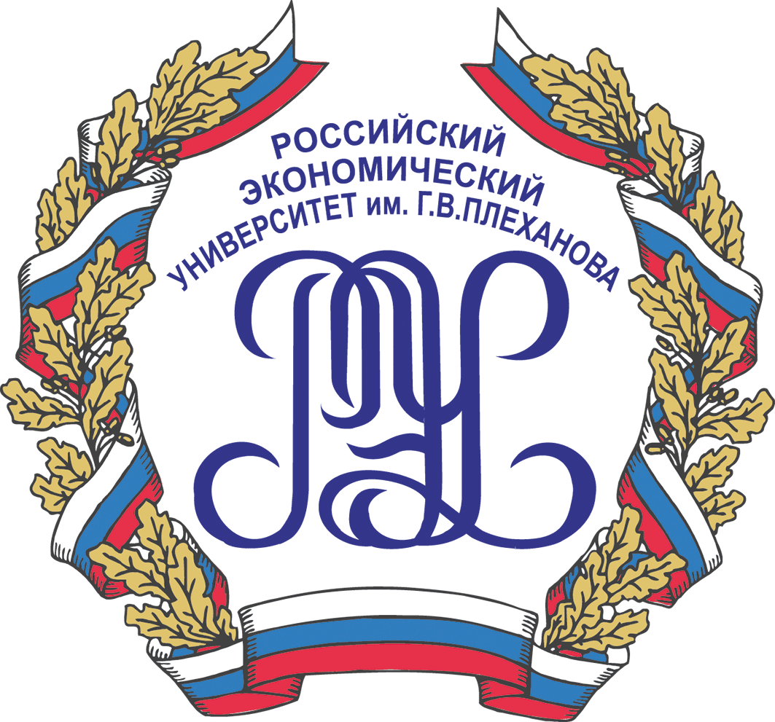 | 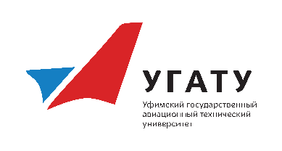

Conference Topics
1. New socio-economic phenomena and processes: economic growth and innovation processes, socio-economic development, corporate structures, financial markets, labor markets, the economy of informal markets, economics and law, environmental and economic mechanisms, social relations and the diversity of society, economics education, digital economy.
2. Methodology, concepts and tools of economic analysis: macroeconomic modeling, knowledge economy and economy of innovation processes, concepts and methods of institutional analysis, models of artificial societies, intellectual property, theory of the firm, stationary and non-stationary economic processes, system analysis, mathematical methods of operations research, methods of economic measurements and statistical data processing, econometrics, prediction methods, theoretical approaches on management models.
3. Applied problems and methods of socio-economic management systems: methods of decision-making, strategies and mechanisms of government regulation of the economy, strategies and actual problems of industrial, territorial and organizational development, social policy.
Conference session formats:
• plenary sessions
• discussions
• round tables
• sections
• master classes and lectures for students, graduates and postgraduates.

Plenary meeting and round tables reports will cover a wide range of theoretical and applied issues, related to system modeling of socio-economic processes.
Roundtable topics:
• The role of local government in Russia
• HR modeling from ego to ecosystem
Discussion topic “Digital economy and modeling of artificial communities”
Sections:
1. Economic theory.
2. Mechanisms of state, regional and municipal government.
3. Modern trends in the development of economic complexes and organizations.
4. Economics of innovation processes.
5. Social policy and labor markets.
6. Financial analysis, banks and investments.
7. Mathematical methods for economic analysis.
Time limits on statements:
• Plenary session (report) - 20-30 min.
• Section (report) - 10-15 min.
• Section (message) - 7-10 min.
• Round table (report) - 15 min.
• Round table (message) –3-5 min.
• Discussions (report) - 15 min.
• Discussions (message) - 5-7 min.
• Lecture, master class - 60-90 min.
Working languages of the conference – Russian, English.

Participation
If you want to participate, please send us an abstract (1 page), an article (4-6 full pages) and an application form to the following email smsep-shatalin@yandex.ru by September 10, 2020. An application form, which should to be fulfilled is given in Appendix 1. Article submission guidelines are provided in appendix 2.
Selection notification: September 22, 2020.
Those wishing to participate in the conference without presentation should send us an application form to the following email smsep-shatalin@yandex.ru by October 1, 2020.
PROGRAMME
12.10.2020 (Monday)
Conference organizers session
13.10.2020 (Tuesday)
Organizing Committee session
13.10.2020 – 18.10.2020 (Wednesday-Sunday)
Work of the conference

For additional information, please contact us by e-mail smsep-shatalin@yandex.ru or on mobile:
+7-910-347-43-10 Solosina Maria
+7-909-217-69-00 Voronova Polina
+7-920-445-43-50 Borodina Anna
+7-980-246-31-71 Kovyrshina Olga

Information letters will be displayed on the websites of the Conference www.smsep.ru, CEMI RAS www.cemi.rssi.ru (https://cemi.online/), VSU www.vsu.ru.

Important Dates
1 | Conference days | 13.10.2020-18.10.2020
2 | Application deadline | 10.09.2020 (without report – 10.01.2020)
3 | Selection notification | 22.09.2020

We would be grateful if you share the information about the conference with all interested parties.
Sincerely Yours,
Organizing Committee

Appendix 1

Application form

Surname
Name
Research interests
Country
Locality
Organization (full name)
Organization address
Position
Academic degree
Academic title
Form of participation in the conference
(With a report / No report)
Co-authors
(If you have co-authors, enter their names in this field. Each co-author should submit a separate application)
Title of the article(s)
Section
• plenary session
• discussions
• roundtable
• sections:
1. Economic theory.
2. Mechanisms of state, regional and municipal government.
3. Modern trends in the development of economic complexes and organizations.
4. Economics of innovation processes.
5. Social policy and labor markets.
6. Financial analysis, banks and investments.
7. Mathematical methods for economic analysis.
phone number
e-mail

Appendix 2

Article submission guidelines
- Abstract (1 page).
- Article (4-6 pages) with the list of references.

For abstract:
Surname First Name (right, font 14, bold)
City, place of work abbreviated (right, font 14, italics)
E-mail (on the right, font 14)
1 interval
TITLE (CAPITAL LETTERS, FONT 14,
BULK, WITHOUT TRANSFER, ALIGNMENT ON CENTER)
1 interval
Annotation text (justified alignment, hyphenation automatic)
…….
1 interval
Keywords:

For article:
Surname First Name (right, font 14, bold)
City, place of work abbreviated (right, font 14, italics)
1 interval
TITLE (CAPITAL LETTERS, FONT 14,
BULK, WITHOUT TRANSFER, ALIGNMENT ON CENTER)
1 interval
Text of the report (alignment by width, hyphenation automatic)
……
1 interval
References:
- ….
- ….

